**<Hotel Search Engine>**

**Software Requirements Specification**

**<CEN 3031, Fall, 2018>**

**Modification history:**

|  |  |  |  |
| --- | --- | --- | --- |
| Version | Date | Who | Comment |
| v1.0 | 10/9/2018 | Alejandro, Robbie | Added more shall statements, use case diagram, program description, use case descriptions, and assumptions |
| v2.0 | 12/04/2018 | Flornaldine | Modify SRS based on final application. |

**Team Name:** Software Operations Specialists

**Team Members:**

* Alejandro Sanchez Padron asanchezpadron0512@gmail.com
* Allen Telson atelson6767@eagle.fgcu.edu
* Flornaldine Pierre fpierre1202@eagle.fgcu.edu
* Chris Bicknese cwbicknese8220@eagle.fgcu.edu
* Robert Darrow rwdarrow4582@eagle.fgcu.edu

**Contents of this Document**

Introduction

* Software to be Produced
* Definition, Acronyms, and Abbreviations

Product Overview

* Assumptions
* Use Case Diagram
* Use Case Descriptions

Specific Requirements

**SECTION 1: Introduction**

Software to be Produced:

* The concept of our project will be creating a Java-based application that provides the user with a built-in search engine that meets the user’s need to find the ideal hotel for their next trip. This search engine should allow the user to find their best hotel match based on their choices of price, location, size, and more. The application should also have a map feature where users will be able to explore hotel options with the map based on their input of locations. The user should also be able to see different prices from the hotel list. The application will include features such as accounts to help differentiate between consumers and hotel owners or representatives that want to look and respond to reviews and feedback from consumers. After finding their ideal hotel, the user will be able to reserve their hotel, choose the dates of the trip and pay for the total price of the trip. Our purpose is to create a finished and robust product that functions with no errors.

Definitions, Acronyms, and Abbreviations:

* None

**SECTION 2:** **Product Overview**

Assumptions:

* Availability of a formatted text file list of all hotel information.
* Running on a machine with Java installed.
* Running on Windows environment.
* Have 1.27 GB of available space.
* Have WiFi internet connection.

Use Case Diagram: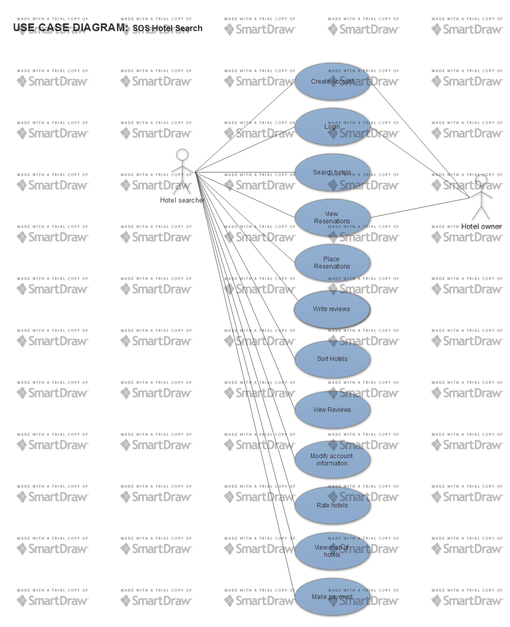

Use Case Descriptions:

* Create account: allow user to enter their personal information to represent themselves in the program, including a preferred password, first and last name, preferred username, date of birth, and email. The account can either be a standard account (for hotel searchers) or business (for hotel owners).
  + Allow user to fill in all fields based on his or her preference.
  + Check to ensure that the username is not taken and fields meet system constraints.
  + If username is taken, notify user to select different username.
* Login: allow the user to enter their username and password to login.
  + Check that the username and password is a match and is contained inside of the database.
  + If the username or password fields aren’t a match or not found, notify user to try again.
* Search hotels: allow user to enter location information to search for hotels in that area.
  + Get hotels within some distance of the specified location to display in the list.
  + If the location is not valid, notify user.
  + Display the hotels in that location on the map.
* View reviews: allow user to view reviews for hotels on the hotel information page.
  + Allow user to select their preferred hotel.
  + Display list of reviews for that hotel.
* Write reviews: allow user to write a review for a hotel.
  + Display textbox for text entry and allow user to select stars (out of 5) to rate their experience.
  + If fields are left blank, notify user to enter in fields.
* View reservations: allows hotel owners to view all reservations for their hotel and hotel users to view their reservations.
* Sort hotels: allow user to sort list of hotels in order based on price.
  + Update list of hotels to reflect new condition.
* Change account information: allow user to modify credentials and information for account.
  + Allow user to modify password, e-mail, full name, and date of birth.

**SECTION 3: Specific Requirements**

|  |
| --- |
| **No:** 1 |
| The system shall require the user to input full name, username, password, date of birth, and email address into fields when creating an account. |
| **No:** 2 |
| The system shall allow the user to select to register as a hotel owner or hotel searcher. |
| **No:** 3 |
| After the user’s credentials are validated, the system shall push the user defined credentials into a database. |
| **No:** 4 |
| The system shall display text fields for the user to enter their preferred username and password to login. |
| **No:** 5 |
| The system shall allow the user to enter an existing location in order to view the hotels in that location. |
| **No:** 6 |
| The system shall display a map in accordance to user-defined location within 10 seconds of user selecting the search button. |
| **No:** 7 |
| The system shall display all reservations stored within a database on the hotel owner account interface. |
| **No:** 8 |
| The system shall display user-written reviews for a specified hotel. |
| **No:** 9 |
| The system shall allow users to enter reviews into text fields for hotels they have reserved. |
| **No:** 10 |
| The system shall display hotels within 20 miles of the specified location when the user chooses to search for a hotel. |
| **No:** 11 |
| The system shall allow users to select an available room from the prefered hotel and make a reservation. |
| **No:** 12 |
| The system shall allow users to a view a list of their existing and past reservations in ascending order. |
| **No:** 13 |
| The system shall allow the user to sort the list of hotels based on price within 2 seconds. |
| **No:** 14 |
| The system shall allow the user to submit a star rating for a hotel. |
| **No:** 15 |
| The system shall allow users to enter in their payment information in order to pay for the reserved hotel. |
| **No:** 16 |
| The system shall allow the user to select a hotel, then subsequently display the hotel name, price, location, and user rating. |
| **No:** 17 |
| The system shall allow the user to place numerous reservations for various hotels. |
| **No:** 18 |
| The system shall display all user credentials on the ‘My account’ scene. |
| **No:** 19 |
| The system shall authorize the user to modify their credentials within the ‘My account’ scene. |
| **No:** 20 |
| The map shall display the specific position of all hotels from the list relative to the user-specified location. |

**CHANGE LOG:**

Originally, one of our requirements specified that the system should allow users to upload pictures of a hotel they reserved, but we did not implement that functionality into our application. One of our other requirements was for the system to display activities around a selected hotel and we also did not implement that.

One of our wants from the very beginning was to have a car pool service but we decided that would be a whole separate system and we would not have enough time to work on that.

Previous Shall Statements numbers 9, 10 and 13-20 did not make into the final product due to time constraints and implementation challenges. These have been updated to reflect the current state of the product.

Template created by G. Walton ([GWalton@mail.ucf.edu](mailto:GWalton@mail.ucf.edu)) on Aug 30, 1999 and last updated Aug 15, 2000; updated by A. Koufakou, Aug 2014

This page last modified by Robert Darrow (rwdarrow4582@eagle.fgcu.edu) on October 12, 2018